- Mealy machiene, output of flip flops effect input

- 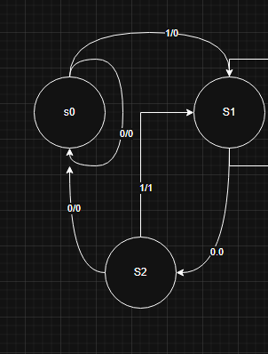
S0 | 00
S1 | 01
S2 | 10
X | Q1​ | Q0​ | Q1+​ | Q0+​ | Z
0 | 0 | 0 | 0 | 0 | 0
0 | 0 | 1 | 1 | 0 | 0
0 | 1 | 0 | 0 | 0 | 0
1 | 0 | 0 | 0 | 1 | 0
1 | 0 | 1 | 0 | 1 | 0
1 | 1 | 0 | 0 | 1 | 1
D.
Q1Q0/X | 0 | 1
00 | 0 | 0
01 | 0 | 0
11 | X | X
10 | 0 | 1
E.
Q1Q0/X | 0 | 1
00 | 0 | 0
01 | 1 | 0
11 | X | X
10 | 0 | 1

Q1Q0/X | 0 | 1
00 | 0 | 1
01 | 0 | 1
11 | X | X
10 | 0 | 1
